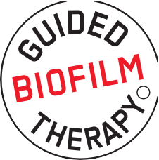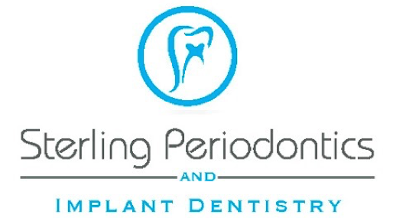
R

Something New During your Dental Visits at Our Office!
Visiting your dental professional is an important part of managing not only your oral health but your overall health as well.

This is why our ofﬁce has invested in a new treatment method that is safe, minimally invasive, and more comfortable for patients.

This advanced system is called Guided Bioﬁlm Therapy.
It utilizes the modern and innovative AIRFLOW® and PIEZON® Swiss-made technologies to help remove bioﬁlm (plaque) and calculus in a more efﬁcient and comfortable way.

Dental bioﬁlm is a colony of bacteria (generally not visible to the naked eye) that builds up on our teeth over time.
Bioﬁlm can travel throughout our bodies and exacerbate many oral and overall health conditions, such as: tooth decay, gum disease, heart disease, diabetes, respiratory illnesses, Alzheimer’s, and autoimmune diseases.

Ineffective removal of the bioﬁlm can lead to further inflammation, infection and overall disease progression.


service@oralscience.com 1.888.442.7070

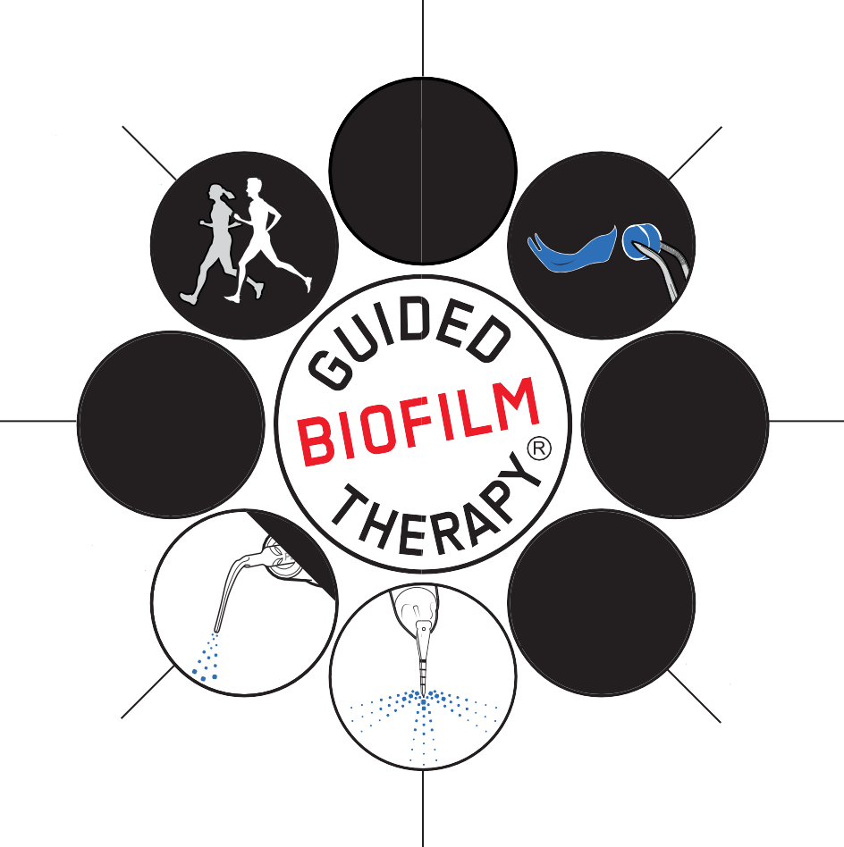ASSESS
01
07
03
05

Evaluating Your Oral Health Status
Your teeth and gums are examined to help determine the right
therapy for optimal treatment and comfort.

DISCLOSE

Making the Bacteria (Bioﬁlm) In Your Mouth Visible
Bioﬁlm is nearly invisible to the naked eye. It can only be removed completely after making it visible with a disclosing solution.

MOTIVATE

Educate and Encourage
Based on your own risk assessment, we will discuss and demonstrate a personal home-care regimen so that you can manage bioﬁlm at home.

AIRFLOW®

Remove Bioﬁlm, Stain, and Early Calculus
EMS AIRFLOW® Max technology combines a gentle powder and warm water to comfortably remove deposits.

PERIOFLOW®

Removing Bioﬁlm Below the Gums
EMS PERIOFLOW® technology removes bioﬁlm from deep periodontal pockets gently and thoroughly.

PIEZON® PS

Remove Remaining Hard Deposits
Gentle removal of calculus/tartar with the PIEZON® PS No Pain
technology.

RE-ASSESS

Final Assessment & Diagnosis
Check to determine if coloured bioﬁlm and calculus have been completely removed; this will assist us in diagnosing cavities.

RE-CARE

Healthy Mouth = Healthy Body
Schedule your next Guided Bioﬁlm Therapy appointment for the same comfortable and efﬁcient maintenance of your overall health.

FLYER-PATIENT-GBT-1

